**Laboratory Nine**



**Javier Jesús Macossay-Hernández**

**EE348L – Electronic Circuits**

**University of Southern California**

**Professor Susan Schober**

**Introduction**

In this laboratory, implementation of hand analysis and HSPICE simulations were done to understand the behavior of BJT amplifier circuits. Furthermore, the amplifier was built in the lab and different tests were done to corroborate our hand calculations and simulation results. Since we used a BJT transistor, the circuit was correctly biased so that the circuit can function as desired.

Exercise 1

**Procedure**

The following circuit was built, a common-emitter amplifier. In the design used, Ree = 183 Ω, Rc = 1.83 kΩ, and Rb1 = 5.5 kΩ. Additionally, the capacitors were equal to 0.1 μF.

**Data**

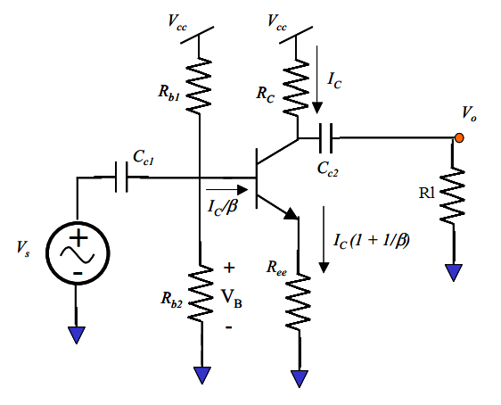

Common-Emitter Amplifier

|  |  |
| --- | --- |
| **Input Amplitude (mV)** | **Gain (V/V)** |
| 100 | 9.5 |
| 200 | 9.3 |
| 250 | 9.2 |
| 300 | 8.6 |

Changing the input amplitude from 100 mV to 300 mV

**Questions**

The current through the emitter obtained was 2.5 mA. Unfortunately, the gain obtained was 9.1 V/V, which is not in the desired 5% range of desired values. To obtained the desired gain, the value of Rb2 was changed to 0.99 kΩ.

The first three data points shows that the circuit behaves linearly between input amplitude and gain, which are inversely proportional. As amplitude increases, gain decreases. The final data point, 300 mV, shows that the trend breaks and the linear behavior is lost.

**Discussion**

It cannot be observed if the circuit behaves linearly or not because not sufficient data points were taken during the laboratory session. However, the data obtained from the experiments yields that the circuit is not linear for high input amplitudes.

Exercise 2

**Procedure**

For the previous circuit, different values for resistance loads where used and the gain was measured.

**Data**

|  |  |
| --- | --- |
| **RL (Ω)** | **Gain (V/V)** |
| 50 | 0.64 |
| 100 | 0.87 |
| 1k | 3.69 |
| 10k | 8.51 |

**Questions**

From the prelab, the gain was expected to increase as the load resistance values increased as well. Satisfactorily, the laboratory results agree with the results from the prelab exercises.

**Discussion**

The circuit worked as desired, which yields to an augmentation of gain as the value of the resistance load increments.

Exercise 3

**Procedure**

A 0.1 μF capacitor was shunt across Ree of the previous circuit and its gain was analyzed.

**Data**

|  |  |
| --- | --- |
| **Frequency (kHz)** | **Gain** |
| 1 | 4.81 |
| 6 | 11.34 |
| 11 | 14.01 |
| 16 | 16.54 |
| 21 | 18.85 |
| 26 | 21.94 |
| 31 | 25.26 |
| 36 | 28.01 |

**Questions**

From the prelab results, an increment in the gain was expected by adding the capacitor to the circuit. At low frequencies and high frequencies, the BJT fails.

**Discussion**

The table that shows the relationship between frequencies and gain where the capacitor reduces gain at low frequencies. Additionally, on high frequency the circuit failed on the oscilloscope as expected.

Exercise 4

**Procedure**

The following circuit was built, an emitter-follower amplifier. In the design used, Ree = 182 Ω, Rc = 1.82 kΩ, and Rb1 = 5.4 kΩ. Additionally, the capacitors were equal to 0.1 μF. Finally, gain was calculated across the load resistance.

**Data**

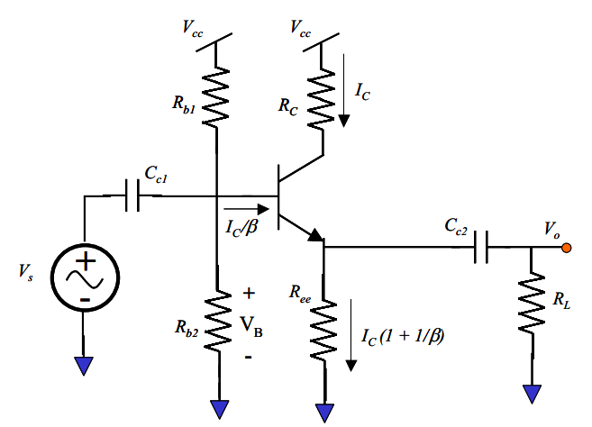

Common-Emitter Amplifier

**Questions**

The gain of the circuit is 0.9, which is almost unity.

Exercise 5

**Procedure**

A load resistance was added to the previous circuit and the gain was measured. The values of the load resistances used were 10kΩ, 1kΩ, 100 Ω, and 50 Ω.

**Data**

|  |  |
| --- | --- |
| **Load Resistance (Ω)** | **Gain** |
| 50 | 0 |
| 100 | 0.92 |
| 1k | 1.92 |
| 10k | 2 |

**Questions**

The circuit will work better with lower load values. In addition, small load resistance will not drive with a common-emitter circuit because it will not work.

**Discussion**

The gain is proportional to the value of the load resistance as seen in the table. As the load resistance increases, the gain increases.

Exercise 6

**Procedure**

The following circuit was built, but Rc was replaced by a potentiometer. The value of the potentiometer was changed until the maximum gain was achieved while maintaining a collector-base reverse bias to ensure linearity.

**Data**



Common-Emitter Amplifier

**Questions**

135 kΩ is the value of the potentiometer to achieve maximum gain.

**Discussion**

The gain is 17.

**Conclusion**

The results clearly agree with the objective of the lab that is to learn how BJTs behave. In addition, we use HSpice and WaveView Analyzer to corroborate our hand calculations and our measured values.